Physics 30 Lesson 17 Parallel Plates

# Parallel plates − uniform electric fields

When two metallic plates are set a distance apart and are then hooked up to a potential difference, a battery in this case, one plate will have a positive charge and the other plate will have a negative charge. The electrostatic forces of repulsion of like charges, within each plate, cause the charges to dis­tribute evenly within each plate, and electrostatic forces of attraction between the two plates cause the charges to accumulate on the inner surfaces. The electric field will be directed away from the positive plate and toward the negative plate. The electric field between the plates is **uniform** throughout. That means the electric field strength is the **same everywhere** inside the parallel plates. Only at the ends of the plates will it show a non-uniform field. Such a system is called a **parallel-plate capacitor**.

+

–

+

+

+

+

+

+

+

+

+

+

-

-

-

-

-

-

-

-

-

-

battery

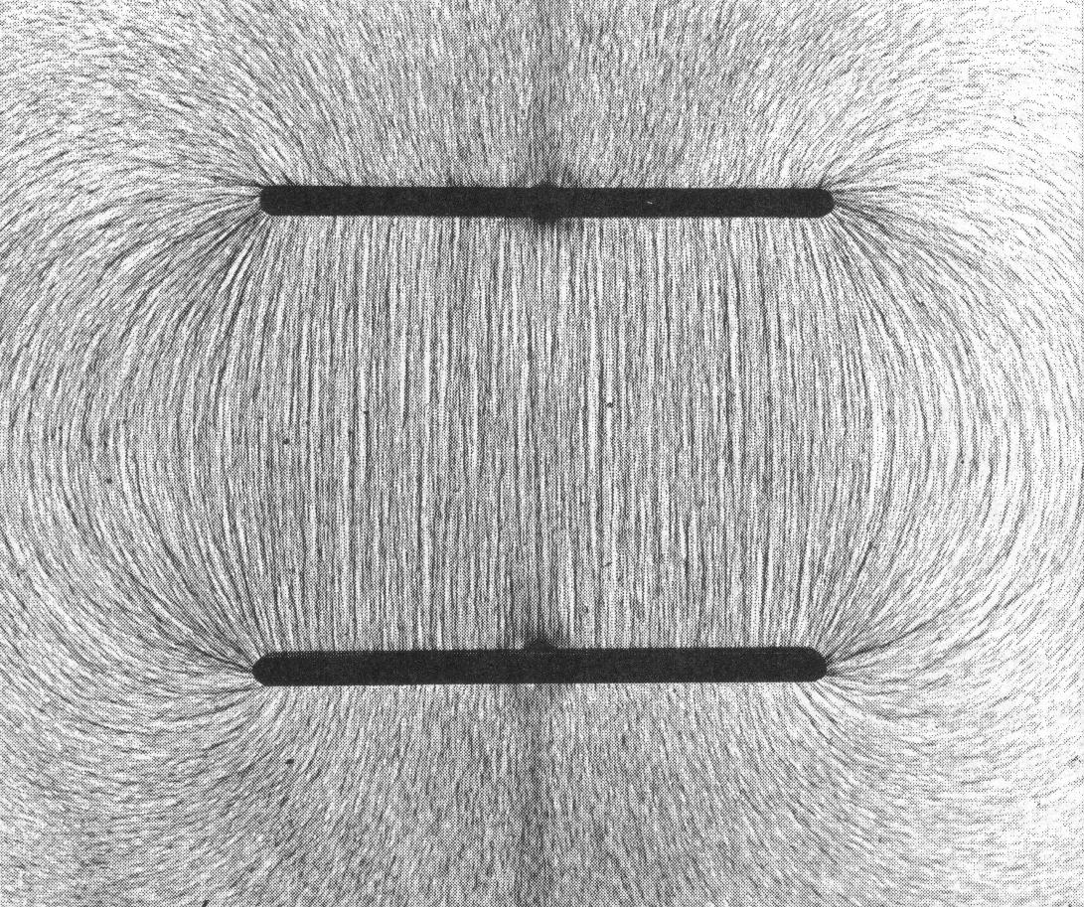

+ plate

– plate

The electric field strength between two charged parallel plates is given by the equation:

 where = field strength ( or )

V = potential difference across plates (Volts)

d = distance between plates (m)

Note:

1. This formula can only be used for electric fields that are uniform or between parallel plates. This formula does not apply to point charges and charged spheres since they do not produce uniform fields.

A potential difference of 8 000 V is applied across two parallel plates set 5.0 mm apart. What is the acceleration on an electron placed in the field.



The electric field strength between two parallel plates is 930 V/m when the plates are 7.0 cm apart What is the electric field strength when the plates are moved to a point where they are 5.0 cm apart?



# Parallel plates − Potential difference

Parallel plates are also excellent sources of a potential difference for the acceleration of electrons, protons, and other particles. In these cases, we can use the principle of the conservation of energy – electric potential energy is transformed into kinetic energy.

An alpha particle with an initial speed of 7.15 x 104 m/s enters through a hole in the parallel plate between two plates that are 0.090 m apart as shown below. If the electric field between the two plates is 170 N/C, what is the speed of the alpha particle when it reaches the negative plate?

The simplest solution method is to use conservation of energy principles.



An alpha particle is placed between two parallel plates set 4.0 cm apart with a potential difference of 7 500 V across them. What is the maximum speed that the alpha particle could achieve in this field?



In order to achieve maximum speed the alpha particle would have to travel from the positive plate to the negative plate. Its potential energy would be completely converted to kinetic energy. (Notice that the plate separation does not matter for this kind of problem.)

# Electric forces and gravitational forces

Quite often the electrostatic forces are so large when compared to the gravitational force involved, we can then ignore the gravitational force. In examples 1, 3 and 4 above, the gravitational forces on protons, electrons and alpha particles are very small compared to the electric forces acting on them. In general:

1. Any time you are given the mass of the particle, calculate both the gravitational and electric forces and compare them. If the gravitational force is less than 1000 times the electrical force, then it is safe to ignore the gravitational force.
2. Any time a massive particle is suspended or moving vertically in an electric field between parallel plates, gravity is a factor.
3. Any time a massive particle is accelerating upward or downward in an electric field between parallel plates, gravity is a factor.

An unknown charge is placed onto a 0.050 mg particle The particle is placed between two horizontal plates set 8.0 mm apart with a potential difference of 5 000 V across the plates. If the particle is suspended between the plates, what is the charge on the particle? How many excess electrons are on the particle?



+ + + + + + + + + +

- - - - - - - - - - - - -

•



To remember how to properly solve problems of this kind, it may be wise to review Physics 20 – Lesson 17 on vertical force problems.

# Millikan’s oil-drop experiment

In 1897, J. J. Thomson measured the charge to mass ratio of an electron (we will study his experiment in detail in Lesson 26). At that time, neither the charge nor the mass of an electron were known – all that physicists knew was the ratio of these values. A few years later, between 1906 and 1913, R. A. Millikan used the suspension of charged particles between parallel plates as a way to determine the charge of the electron. This experiment is referred to as an *oil drop problem* and it is solved in the same manner that Example 5 was solved. (Refer to Pearson pages 761 to 765.)

The basic design of Millikan’s experiment involved two parallel plates, a distance (d) apart, hooked up to a variable voltage source where the voltage could be adjusted to provide just enough of an electric force to balance the force of gravity on the oil drop. An atomizer sprayed tiny oil droplets between the plates. In addition, friction between the droplets and the atomizer’s plastic nozzle gave the droplet a small static charge. Using a small microscope, Millikan could observe the motion of the droplets and he could also measure the size of the droplets. From the droplet’s radius and the density of the oil he could determine the mass of the droplet.

+ + + + + + + + + +

- - - - - - - - - - - - -

•

FE

Fg

oil drop with a (–) charge

+

-

variable voltage

atomizer

When the droplet is motionless, the electric and gravitational forces are balanced.



Along with these calculations and measurements, Millikan made a number of educated assumptions:

1. All electrons are identical – each has the same amount of charge.
2. The mass of each electron is so small that the addition or subtraction of a few will not significantly change the mass of the oil droplet.
3. The amount of charge on the oil droplet will be a whole number multiple of the charge of one electron (i.e. 2 e, 7 e, 12 e, etc.).

Using this apparatus, Millikan came up with a value of 1.69 x 10-19 C for the charge on an electron. This value is fairly close to the presently accepted value of 1.60 x 10-19 C.

# Practice problems

1. A potential difference of 8000 V is applied across two vertical parallel plates set 5.0 mm apart. What is the acceleration of a proton placed in the field? What is its final speed if it started at rest? (1.53 x 1014 m/s2, 1.24 x 106 m/s)

2. A proton is placed in an electric field between two parallel plates set 6.0 cm apart with a potential difference of 75 V across the plates.

A. How much work is done if the proton is moved 3.0 cm parallel to the plates? (0)

B. How much work is done against the electric field if the proton is moved 3.0 cm perpendicular to the plates? (6.0 x 10-18 J)

C. If the proton is released at the positive plate, what will its speed be when it impacts on the negative plate? (1.2 x 105 m/s)

3. An oil drop whose mass is 5.70 x 10-16 kg accelerates upward at a rate of 2.90 m/s2 when placed between two horizontal parallel plates that are 3.50 cm apart. If the potential difference between the plates is 7.92 x 102 V, how many electrons are on the drop? (3.2 x 10-19 C, 2e-)

4. In a Millikan oil drop experiment a student sprayed oil droplets between two horizontal plates that were 4.0 cm apart. The student adjusted the potential difference between the plates to 4.6 x 103 V so that one of the drops became stationary. If the mass of the drop was 5.63 x 10-15 kg, what was the magnitude of the charge on this oil drop? (4.8 x 10-19 C, 3e-)

# Hand-in assignment

1. What is the electric field intensity between two large parallel plates 2.0 cm apart, if a potential difference of 450 V is maintained between them? (2.3 x 104 N/C)

2. What potential difference applied between two parallel plates will produce an electric field strength of 2.5 x 103 N/C, if the plates are 8.0 cm apart? (2.0 x 102 V)

3. How far apart are two parallel plates if a potential difference of 600 V produces an electric field intensity of 1.2 x 104 N/C between them? (5.0 x 10-2 m)

4. An oil drop, of mass 2.6 x 10-15 kg, is suspended between two parallel plates 0.50 cm apart, and remains stationary when the potential difference between the plates is 270 V. What is the charge on the oil drop, and how many excess or deficit electrons does it have? (4.7 x 10-19 C, ± 3 electrons)

5. A metallic Ping-Pong ball, of mass 0.10 g, has a charge of 5.0 x 10-6 C. What potential difference, across a large parallel plate apparatus of separation 25 cm, would be required to keep the ball stationary? (49 V)

6. A Ping-Pong ball of mass 3.0 x 10-4 kg is hanging from a light thread 1.0 m long, between 2 parallel plates 10 cm apart (as shown to the right). When the potential difference across the plates is 420 V, the ball comes to equilibrium 1.0 cm to one side of its original position.

10 cm

1.0 m

1.0 cm

a) What is the electric field intensity between the plates? (4.2 x 103 N/C)

b) What is the tension in the thread? (2.9 x 10-3 N)

c) What is the magnitude of the electric force deflecting the ball? (2.9 x 10-5 N)

d) What is the charge on the ball? (7.0 x 10-9 C)

7. Four parallel plates are connected, in a vacuum, as shown. (In circuit diagrams, the short line on the battery symbol represents the negative terminal, and the long line represents a positive terminal.)

– •

300 V

500 V

4.0 cm

4.0 cm

X

W

Y

Z

An electron, essentially at rest, drifts into the hole in plate X and is accelerated to the right. Assuming that it’s vertical motion is negligible, it passes through hole W, goes through hole Y, and then continues moving towards plate Z. Using the dimensions and potential differences given in the diagram, calculate:

a) the velocity with which the electron passes through hole W (1.0 x 107 m/s)

b) the velocity with which it passes through hole Y (1.0 x 107 m/s)

c) the distance from plate Z of the point where the electron momentarily comes to rest (1.6 cm to the left)

d) the velocity with which it arrives back at plate X

8. An oil drop weighs 3.84 x 10-15 N. If it is suspended between two horizontal parallel plates where the electric field strength is 1.20 x 104 N/C, what is the magnitude of the charge on the oil drop? (3.2 x 10-19 C, 2e-)

9. An oil drop whose mass is 3.50 x 10-15 kg accelerates downward at a rate of 2.50 m/s2 when placed between two horizontal parallel plates that are 1.00 cm apart. Assuming that the oil drop is negatively charged and that the top plate is positive, how many excess electrons does the oil drop carry if the potential difference between the plates is 5.38 x 102 V? (4.76 x 10-19 C)

10. An oil drop with one e- of charge and a mass of 9.36 x 10-15 kg accelerates upward at 5.20 m/s2 toward the positive plate when released. If the plates are set 15.0 mm apart, what is the potential difference applied across the plates? (1.32 x 104 V)

11. An oil drop with a mass of 7.20 x 10-16 kg is moving upward at a constant speed of 2.50 m/s between two horizontal parallel plates. If the electric field strength between these plates is 2.20 x 104 V/m, what is the magnitude of the charge on the oil drop? (3.20 x 10-19 C)

12. The electric field strength between two parallel plates set 20 mm apart is 1.00 x 105 N/C. The potential at the negative plate is -1 000 volts. Draw the equipotential lines between the two plates for every 250 volt increase in potential from the negative plate to the positive plate. If a proton is released from rest midway between the plates, with what speed will it reach the negative plate?

(4.4 x 105 m/s)

13. Two horizontal plates are separated by a distance of 4.00 cm. The electric potential between the plates is 120 V. A horizontal beam of electrons, with a speed of 6.50 x 106 m/s, is directed into the electric field between the plates. The electrons enter the field 1.00 cm above the negative plate.

+ + + + + + + + + + + + + + + + + + + + + + + +

3.00 cm

Electron beam

1.00 cm

– – – – – – – – – – – – – – – – – – – – – – – – –

Draw the resulting path of the electron beam. Determine the horizontal distance that the electrons travel before striking the positive plate. (The diagram is not drawn to scale.) (6.94 cm)